Report Fact Table Techniques

by Aliaksandr Labayeu

# Data

Steps of generating data:

## Applying STAR database structure

Structure was automatically generated from SPARX Enterprise Architect and compiled in SQL Developer.

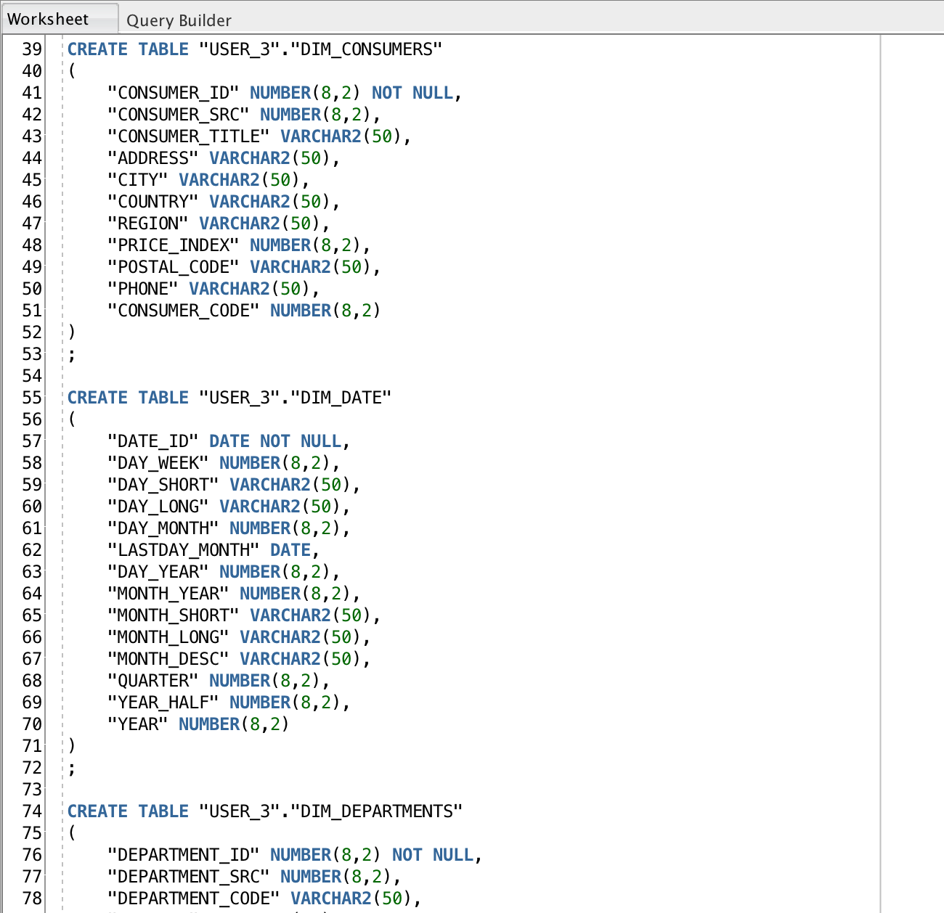

## Using DROP package procedure

DROP package procedure is used to drop all objects no mater they exist or not.

Framework is applied to the structure.

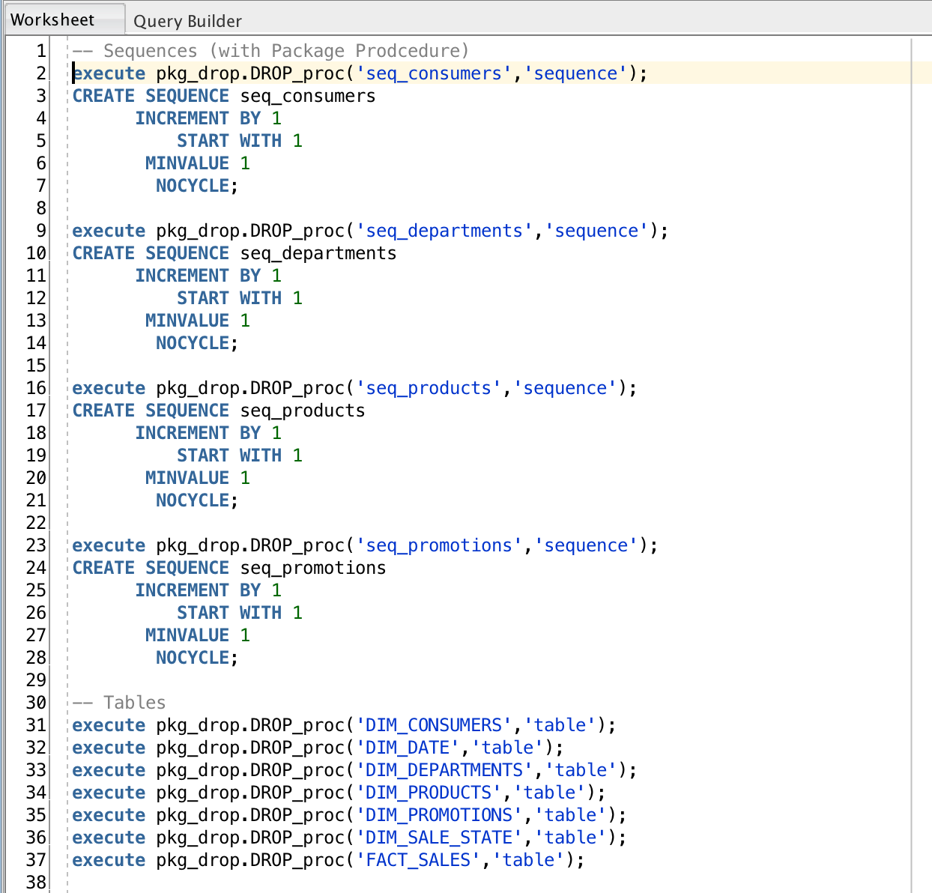

## Creating procedure of INSERTing data

Procedure includes deletes and inserts of random or sh/hr schema values

* During the process of inserting data in fact by level, oracle almost stopped working on the main EPAM machine, so it was used no to investigate other methods of randomizing data on own computer and simple dbms.randoms with not wide-ranged level are presented in script.

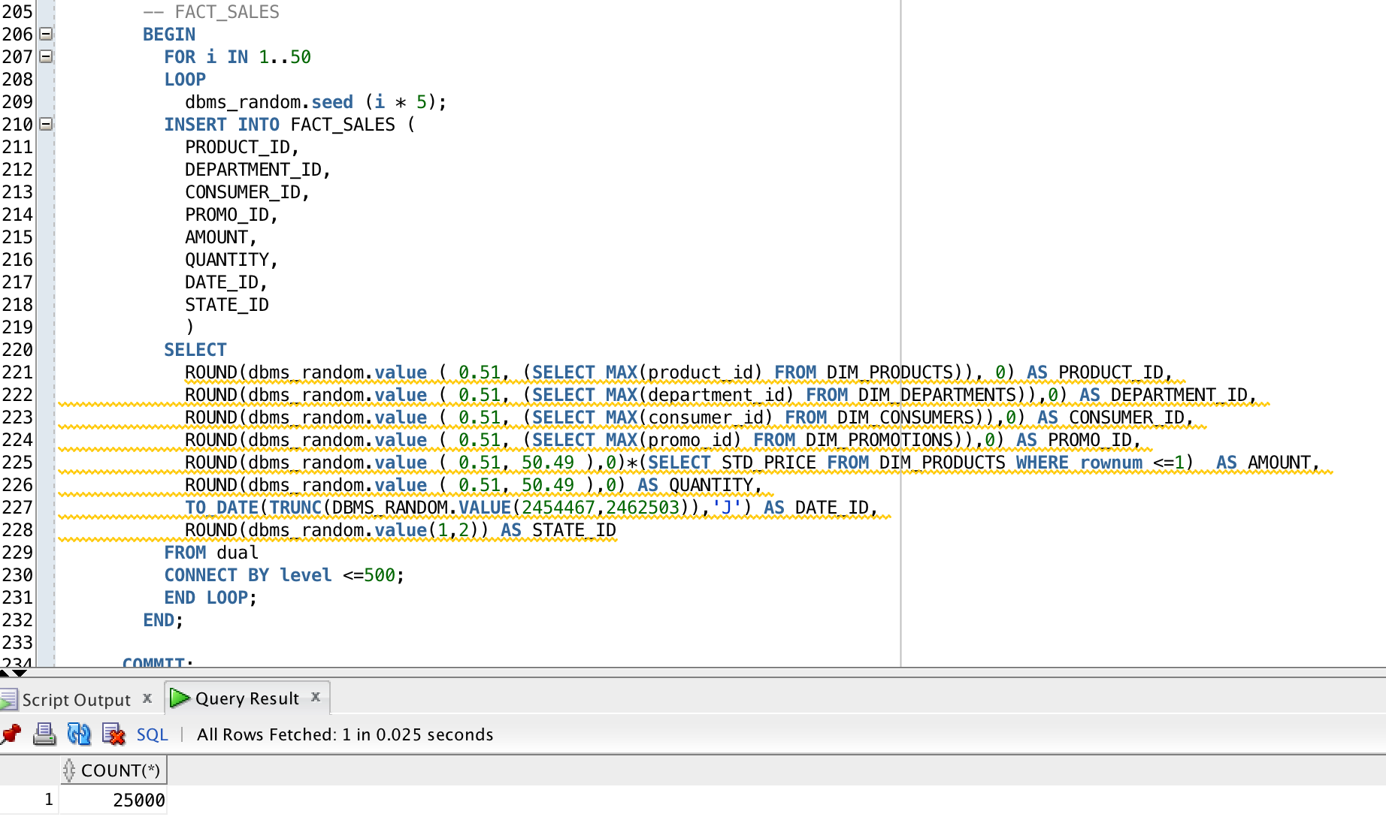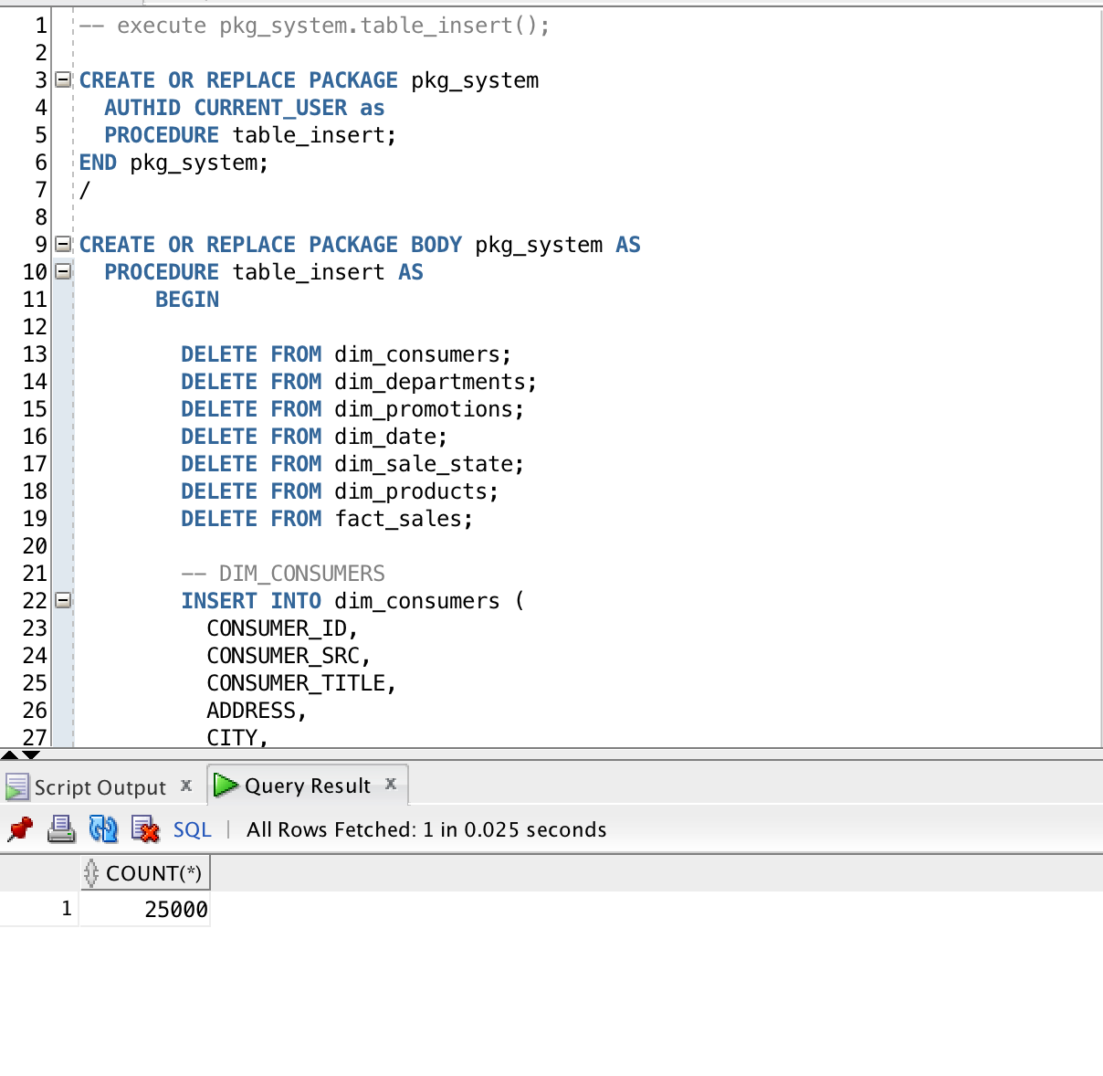

All generated data is very similar to the data that will be used in main DWH.

# Advanced Grouping tasks

## Daily Report

Investigating total amount and quantity sold for each department and its total

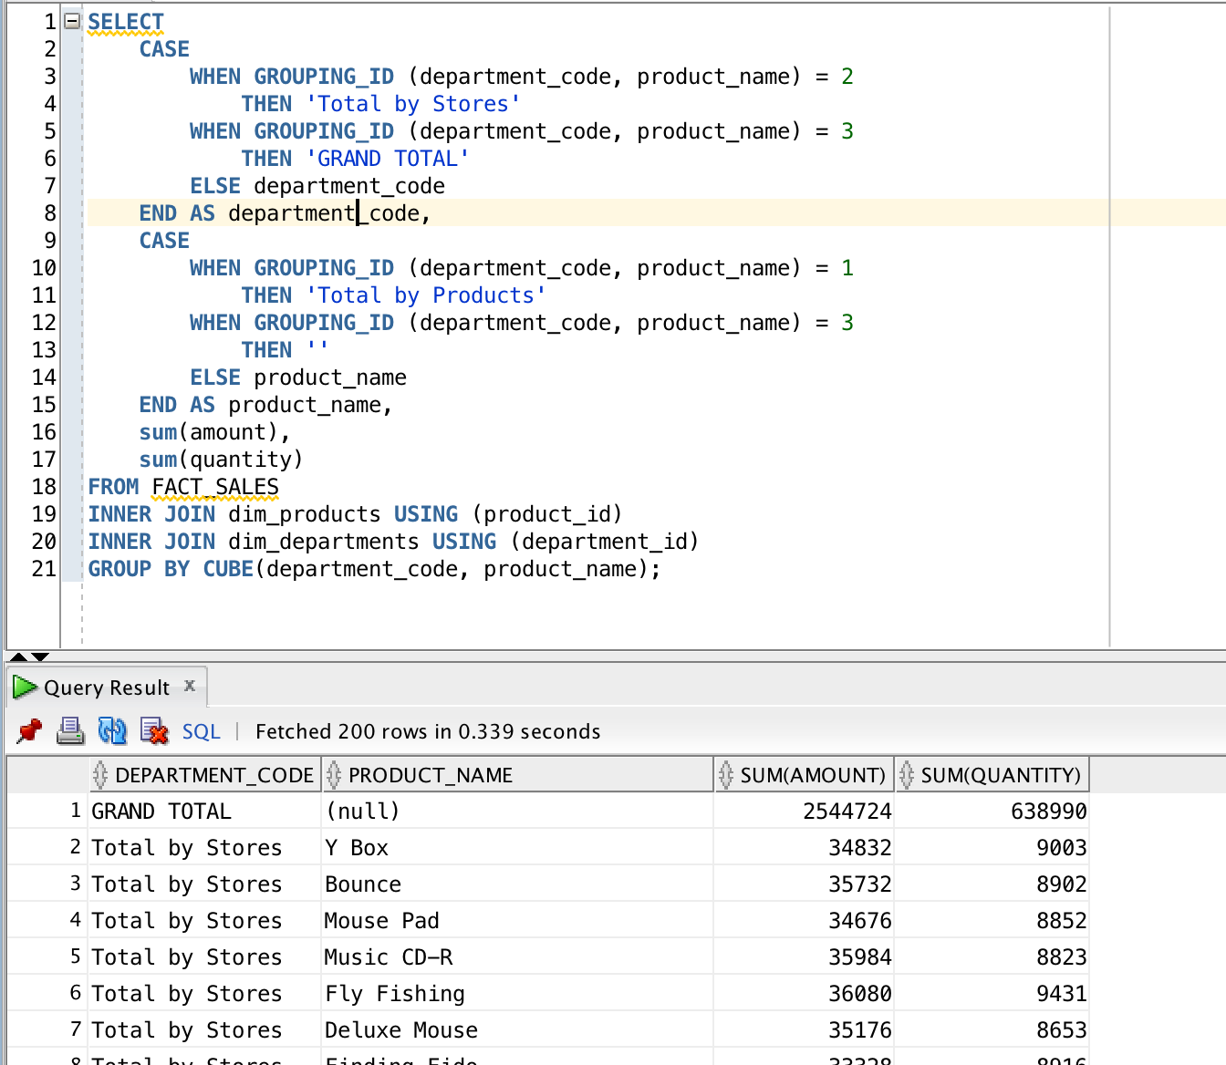

## ROLLUP by Time

investigating total amount and quantity sold on year, quarter, month, day and total

